Character Matters: Developing Students’ Habits of Mind

After School Professional Development Program (ASPDP) registration required
New York City district participants seeking P/A+ credits towards a Master’s +30 or any other salary differential must complete additional registration with ASPDP. When available, register for the course on the ASPDP website during the semester you are completing coursework. The ASPDP course catalog is found here: https://pci.nycenet.edu/aspdp/Course/Search.

Credits earned upon completion of semester coursework
Earn 3 P/A+ Credits and 45 CTLE hours upon successful completion of semester coursework. Time spent engaged in the course is reviewed by our instructors and staff members.
To start your online coursework
First, purchase on quikitech.com the individual course or a multi-course bundle (you will be able to select the course as part of your course bundle when the semester begins). Second, log in to your Quikitech account to access your course link.

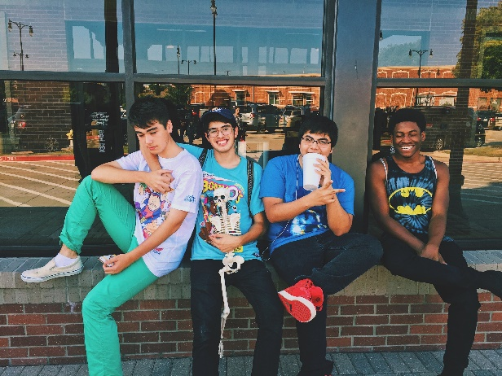
Course Description: “Character Matters: Developing Students' Habits of Mind” provides in-depth exploration of universal factors of success: character traits and ways of thinking that can be fostered and developed through guidance and practice that enable people to triumph over adversity and behave with integrity when faced with problems. You’ll learn:
- Various secrets of success, including kindness, resiliency, and mistake-making
- How to foster healthy habits of mind in your students
- How habits of mind are key in keeping students on a pathway to fulfilling their potential – a key aspect of equity in education
This course by no means addresses an exhaustive list of important habits of mind - that would be impossible in the given parameters. However, a selective list was created that can particularly boost students’ perspectives, attitudes, work ethic, and achievement.

Course Outline: This course consists of 7 sessions.

Session 1: Course & Content Introduction (including introduction of participants!)
Session 2: Habits of Mind (A)
- Persistence
- Empathy
- Kindness
Session 3: Habits of Mind (B)
D. Self-control
E. Attentive, deliberate listening
F. Metacognition
Session 4: Habits of Mind (C)
G. Curiosity
H. Respect
I. Learned, responsible optimism
Session 5: Habits of Mind (D)
J. Growth mindset
K. Humor
L. Audacity
Session 6: The Critical Role of the Teacher in Developing Habits of Mind
Session 7: Final Project & Course Conclusion

Aligned with Danielson’s Framework, including the following components:
- 1b Demonstrating Knowledge of Students
- 3e Demonstrating Flexibility and Responsiveness
- 2d Managing Student Behavior

Aligned with Next Generation Standards, including:
NYS NGS Speaking & Listening Anchor Standards:
- STANDARD 1: Prepare for and participate effectively in a range of conversations and collaborations with diverse partners; express ideas clearly and persuasively, and build on those of others.

Any questions? Please ask our Support Team at support@quikitech.com.

